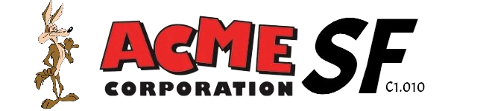

February 15th, 2024

Testing wis

**Repository: https://github.com/C1-010/Acme-SF-D01**

Group: C1.010

García Rivero, Andrés - [andgarriv@alum.us.es](mailto:andgarriv@alum.us.es)

López Cubiles, Antonio José - [antlopcub@alum.us.es](mailto:antlopcub@alum.us.es)

Nieto Vicioso, Javier - [javnievic@alum.us.es](mailto:javnievic@alum.us.es)

Díaz Ordoñez, Pablo -  [pabdiaord@alum.us.es](mailto:%20pabdiaord@alum.us.es)

Sevillano Barea, Alejandro - [alesevbar@alum.us.es](mailto:alesevbar@alum.us.es)

Content Table

1. Executive Summary 2

2. Revision Table 2

3. Introduction 2

4. Contents 2

5. Conclusions 2

6. Bibliography 2

# 1. Executive Summary

This report is about the prior knowledge that our working group had about what they knew about testing a WIS before starting this project and this subject.

# 2. Revision Table

|  |  |  |
| --- | --- | --- |
| Revision number | Date | Description |
| 1 | [15/02/2024] | Creation of the report and completion of its first version. All required information has been provided. |
| 2 |  |  |

# 3. Introduction

# We are facing a report about the prior knowledge we had about testing a WIS architecture before entering and starting the Design and Testing II course. Regarding the structure of this document, we find an Executive Summary, followed by a Review Table, the content of the report, which in this case focuses on our prior knowledge of WIS architecture testing. Finally, there is a conclusion that has been reached, and lastly, the bibliography.

# 4. Contents

**4.1 Our prior knowledge about testing a WIS architecture before starting this journey in the subject.**

Most of the members of our working group did not have extensive knowledge about testing a WIS (Web Information System) architecture. Mainly, the only thing we were somewhat familiar with was the division into three tiers that is presented: the presentation tier, the application tier, and the database tier. As for the components of the architecture, we did not have exhaustive knowledge, but we inferred what components could exist in each of the three tiers presented, such as a database or some server or application with which we would manage the software. Upon concluding about the interactions between the tiers, we had an idea of possible behaviors among them, but we did not know it with a more specific character.

# 5. Conclusions

As a conclusion to this report on our prior knowledge, we can affirm that we did not have a very extensive understanding of testing this type of architecture. We possessed a basic knowledge of it, which has been enhanced through the studied introduction at the beginning of the course. We believe that during the completion of this project and with the progression of the course, we will be able to learn even more about testing the WIS architecture.

# 6. Bibliography

Intentionally blank.